*Course title: Computer Graphics Lab*

*Course code: CSE-304*

*3rd Year 1st Semester Examination 2022*

**Date of Submission**: 28 May 2023

**Submitted to**

**Dr. Mohammad Shorif Uddin**

*Professor*

**Dr. Morium Akter**

*Associate Professor*

*Department of Computer Science and Engineering Jahangirnagar University*

*Savar, Dhaka-1342*

**Sl** Class Roll Exam Roll Name 01 408 202220 Sudipta Singha

**Code scan conversion of point:**

from matplotlib import pyplot as plt

x=int(input("Enter x coordinate"))

y=int(input("Enter y coordinate"))

X_cor=[]

Y_cor=[]

X_cor.append(x)

Y_cor.append(y)

plt.plot(X_cor,Y_cor,marker="o",markersize=10,markerfacecolor="blue") plt.show()

**Screenshot:**

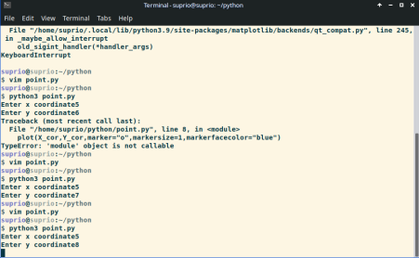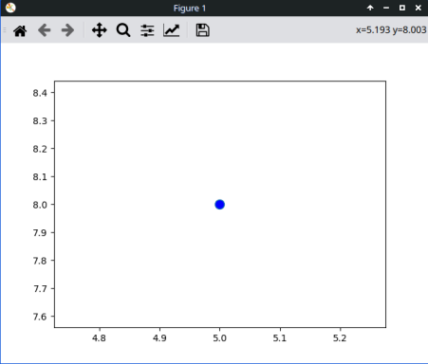

**Code DDA:**

from matplotlib import pyplot as plt

def DDA(x0,y0,x1,y1):

dx=x1-x0

dy=y1-y0

steps=max(dx,dy)

xinc=dx/steps

yinc=dy/steps

x=float(x0)

y=float(y0)

x_cor=[]

y_cor=[]

for i in range(steps):

x_cor.append(x)

y_cor.append(y)

x=x+xinc

y=y+yinc

plt.plot(x_cor,y_cor,marker="o",markersize=1,markerfacecolor="green") plt.show()

x0=int(input("Enter first x_coordinate"))

y0=int(input("Enter first y_coordinate"))

x1=int(input("Enter second x_coordinate"))

y1=int(input("Enter second y_coordinate"))

DDA(x0,y0,x1,y1)

**Screenshot:**

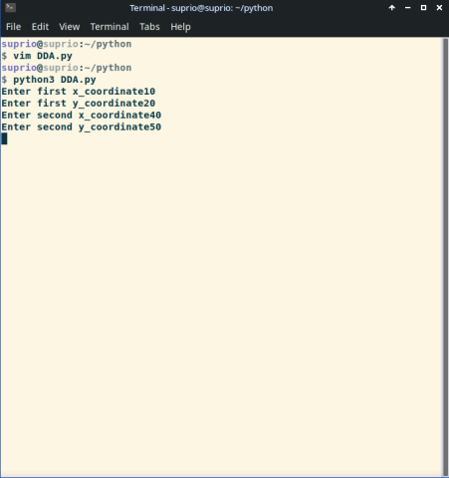

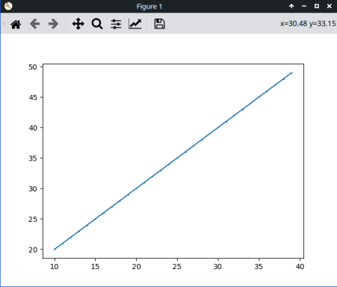

**Brasenhem algorithm:**

from matplotlib import pyplot as plt

def Pixelplot(x0,y0,x1,y1,dx,dy,choose):

P=2 * dy -dx

x_cor=[]

y_cor=[]

for i in range(0,dx+1):

x_cor.append(x0)

y_cor.append(y0)

if(x0<x1):

x0=x0+1

else:

x0=x0-1

if(P<0):

if(choose==0):

P=P+2*dy

else:

P=P+2*dy

else:

if(y0<y1):

y0=y0+1

else:

y0=y0-1

P=P+2*dy-2*dx

plt.plot(x_cor,y_cor,marker="o",markersize=1,markerfacecolor="red") plt.show()

x0=int(input("Enter first x coordinate"))

y0=int(input("Enter first y coordinate"))

x1=int(input("Enter second x coordinate"))

y1=int(input("Enter second y coordinate"))

dx=abs(x1-x0)

dy=abs(y1-y0)

if(dx>dy):

Pixelplot(x0,y0,x1,y1,dx,dy,0)

else:

Pixelplot(y0,x0,y1,x1,dy,dx,1)

**Screenshot:**

